# **Report**

# **Determining Average Calories per Ounces of Cereal Products**

# **Determining Average Calories per Ounces of Cereal Products**

# **Introduction**

Calories consumption is an increasingly important topics for many consumers. As one of the most consumed breakfast food, cereal has an irreplaceable place in many people’s lifestyle (Wunsch, 2022). The knowledge of how much calories in a cereal product can provide a general idea on how consumers can plan their calories consumption. Typically, each cereal product contains information about the calories per serving within it. However, the information may not be available when a consumer is planning the calories consumption prior to buying the cereal products. Having a general idea on how much calories in a cereal products on average will be a very helpful insight.

The goal of this project is to determine the average calories in a cereal products. The population of this project is all cereal products that are available on the market. Since, there may be thousands of cereal products on the market, the project will take 77 sample of cereal products from 7 global cereal manufacturers. People who frequently consume cereal and are trying to determine their calories consumption may find the insight from this project very useful.

# **Methods**

The datasets is obtained from Crawford (2018). The original datasets contain many variables that essentially listed out the nutrition information of each cereal products. For this project, only calories per serving (in kcal) and serving weight (in ounces) will be used for the analysis. Since each cereal product may have different serving weight, it is important to convert the calories per serving data into a same standard in weight. Thus, by dividing the calories per serving with the serving weight, the calories per ounce will be obtained. This are the one variable that will be analyzed.

There are 77 cereal products that is being sampled. First, the project will look at the descriptive statistics using R built-in functions. Then, it will determine the inferential statistics that is necessary to estimate the population parameter using sample statistics. Using sample’s standard deviation, it will calculate the standard error of the mean. Then, it will be used to calculate the 95% confidence interval of the mean.

# **Result**

The descriptive statistics of the sample is calculated using R built-in functions and shown on the table below. The average calories in an ounce of cereal products is 104.0 kcal with 13.852 kcal of standard deviation. Mendenhall et al. () noted that confidence interval can be established using point estimator and the standard error of the estimator multiplied by the desired confidence.

After the standard error of the mean is calculated, the 95% confidence interval of the mean is calculated in between 100.84 kcal and 107.15 kcal.

(Point estimator) (Standard error of the estimator)

Table 1 Descriptive statistics of the calories per ounces in the sampled cereal products

|  |  |
| --- | --- |
| Sample size | 77 |
| Minimum | 50 kcal |
| Lower quartile | 100 kcal |
| Median | 106.7 kcal |
| Mean | 104.0 kcal |
| Upper quartile | 110 kcal |
| Max | 150 kcal |
| Std. Deviation | 13.852 kcal |
| Std. Error of the Mean | 1.5785 kcal |
| 95% Confidence Interval of the Mean | 100.8398 kcal - 107.1540 kcal |

The frequency histogram of the data is shown on the figure 1 below. The histogram shows a shape similar to normal distribution bell-shaped curve which may imply that the sampling distribution follows normal distribution.

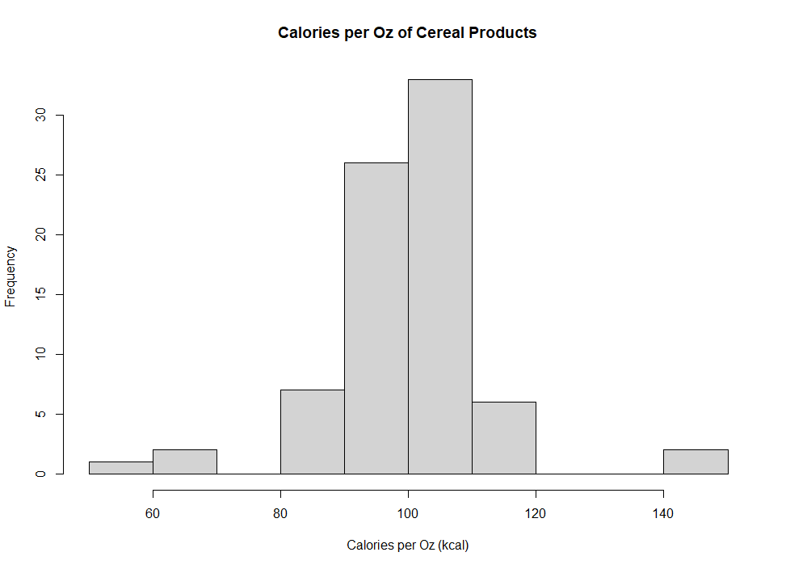

Figure 1 Frequency histogram of the calories per ounce in cereal products

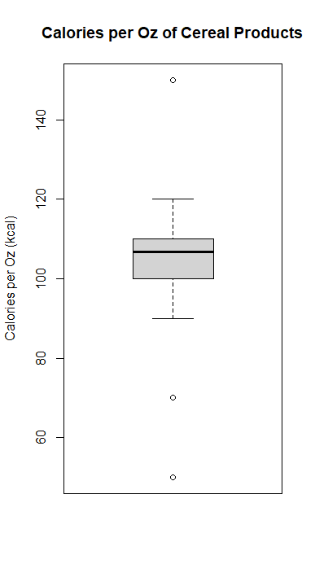

Figure 2 Boxplot of calories per ounce in cereal products

# **Conclusion**

Paragraph 4

# **References**

Crawford, C. (2015). *80 Cereals Nutrition data on 80 cereal products*. Kaggle. https://www.kaggle.com/datasets/crawford/80-cereals

Mendenhall, W., Beaver, R. J., & Beaver, B. M. (2020). *Introduction to Probability and Statistics* (15th ed.). Cengage Learning, Inc.

Wunsch, N. G. (2022, July 4). *Most popular breakfast foods among consumers in the United States in 2022*. Statista. https://www.statista.com/statistics/1311276/most-popular-breakfast-foods-among-consumers-in-the-us/